PilotBuddy: Project Outline

Christopher Gonzalez
Saint Leo University
COM-437 Mobile Application Development
Dr. Marwan Omar
September 6, 2026

PilotBuddy: Project Outline

Project Description
PilotBuddy is an Android application built for general aviation and student pilots that consolidates several flight planning calculations into a single mobile tool. The app performs course reversal calculations (90/180/270 procedure turns), computes crosswind and headwind components from a given runway heading and wind speed/direction, and provides quick-reference airport information, including runway layout and common radio frequencies for a selected airport.

Problem Addressed
Pilots currently rely on paper E6B flight computers, printed charts, or separate apps to perform these tasks during preflight planning and in the cockpit. Manually working through wind triangle math or looking up airport data across multiple sources is slow and increases the chance of error, particularly under time pressure such as during an instrument approach course reversal. PilotBuddy addresses this by placing the three most frequently needed calculations and references into one app, reducing lookup time and the risk of hand-calculation mistakes.

Platform
- Target OS: Android (minimum SDK to be finalized after reviewing current Android Studio defaults, targeting recent Android versions for broadest device coverage).
- Development environment: Android Studio with the Android SDK.
- Language: Java.
- Target devices: Android phones and tablets, since both are commonly used in the cockpit.

Front-End / Back-End Support
- Front end
- Built using standard Android Activities and Fragments for each major function (turn calculator, wind calculator, airport lookup).
- Input fields and numeric pickers for course, heading, and wind values, with results displayed immediately on the same screen.
- Back end
- Turn and wind calculations are computed locally on the device. No server call is required since these are self-contained formulas.
- Airport information (runways, frequencies) is stored in a local SQLite database bundled with the app, structured as an airport table keyed by ICAO/FAA identifier with related runway and frequency records.
- Drawing on prior experience designing relational schemas in SQL Server, the airport data will be normalized into separate airport, runway, and frequency tables rather than one flat table, to avoid repeating airport-level data for every runway or frequency entry.
- A future iteration could replace or supplement the local database with a live aviation data API, but the initial version will use a static, locally stored dataset to keep the app functional without an internet connection.

Functionality
- 90/180/270 Course Calculator
- User enters a given course.
- App returns the resulting heading after a 90, 180, or 270 degree turn in either direction.
- Crosswind / Headwind Calculator
- User enters runway or aircraft heading, plus wind speed and direction.
- App calculates and displays the crosswind component and headwind/tailwind component.
- Airport Information Lookup
- User searches for an airport by identifier.
- App displays runway layout (numbers, length, surface) and common frequencies (CTAF, tower, ground, ATIS) for that airport.

Design (Wireframes)
The app will use a simple tab or menu-based navigation from a home screen to the three core tools. Wireframe sketches will be developed in a design tool and included as image assets in the GitHub Wiki, but the planned screen flow is as follows:

- Home Screen: app title and three navigation buttons, one per tool (Turn Calculator, Wind Calculator, Airport Info).
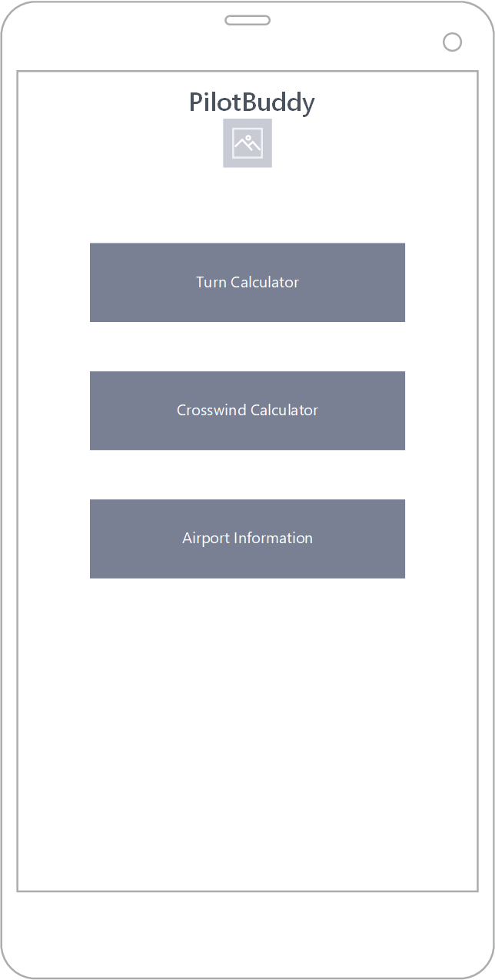
- Turn Calculator Screen: single input field for current course, three result fields for 90/180/270 outcomes.
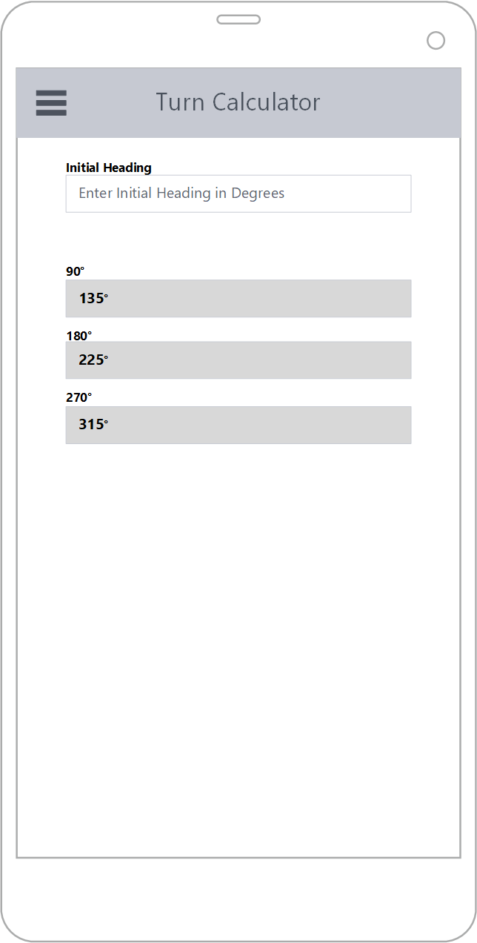

- Wind Calculator Screen: input fields for heading, wind direction, and wind speed, with output fields for crosswind and headwind/tailwind components.
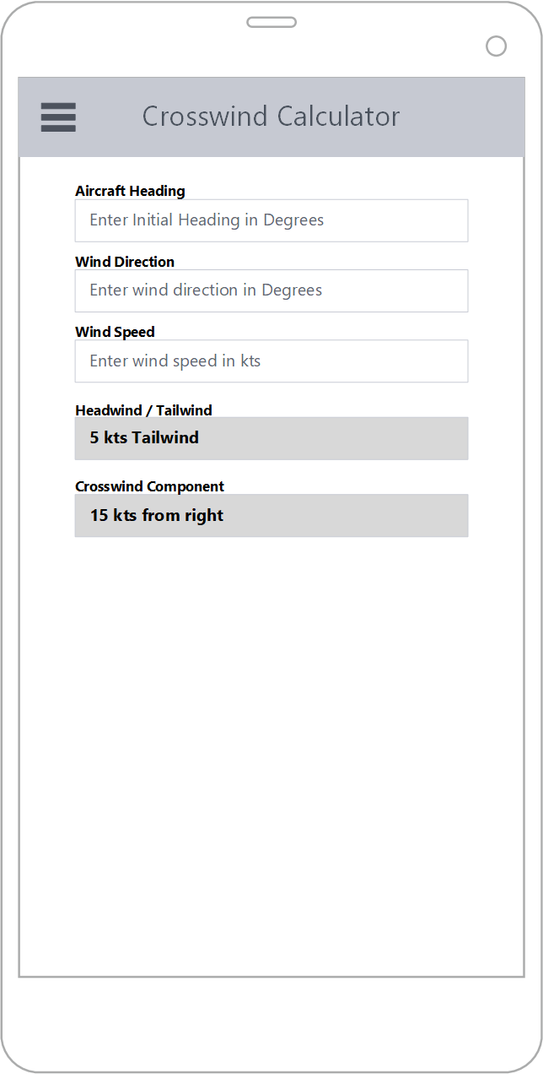
- Airport Info Screen: search field for airport identifier, results area listing runways and frequencies for the matched airport.
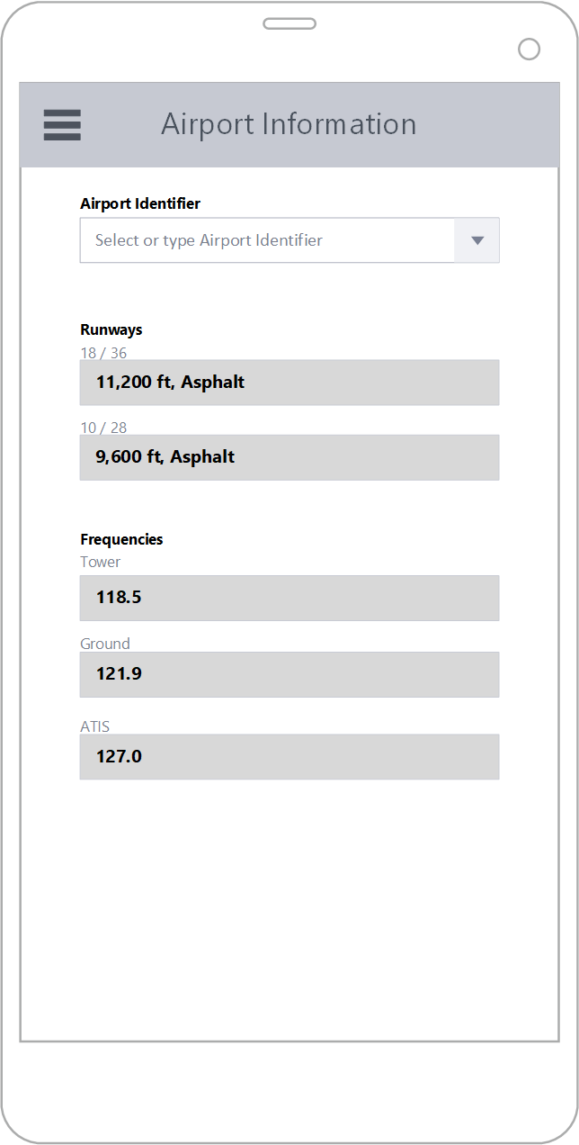

GitHub Documentation
This outline will also be published as the README.md in the project's GitHub repository and republished as a GitHub Wiki page. The README follows the same section structure as this document.
Link to GitHub README: https://github.com/ChrisGonzalez72/PilotBuddy
Link to GitHub Wiki: https://github.com/ChrisGonzalez72/PilotBuddy/wiki

